The Altitude of Polaris

Problem: How does the altitude of Polaris change if you go north or south?
Make a prediction here:

Define Altitude:

Define Constellation:

Define Latitude:

OBSERVATIONS:
Label the Big Dipper, Polaris, and Cassiopeia on the picture below:

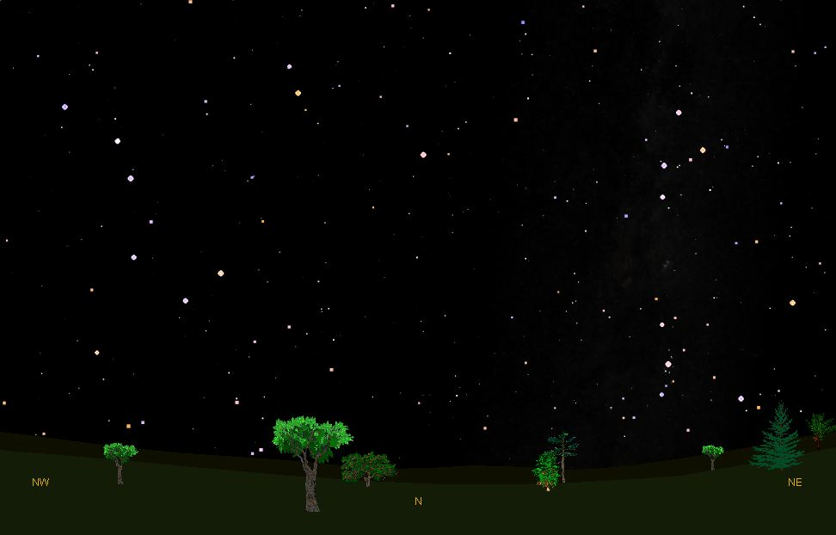

Using a colored pencil, circle the locations we visit on Earth. Use this map to find the latitude of each location we visit.
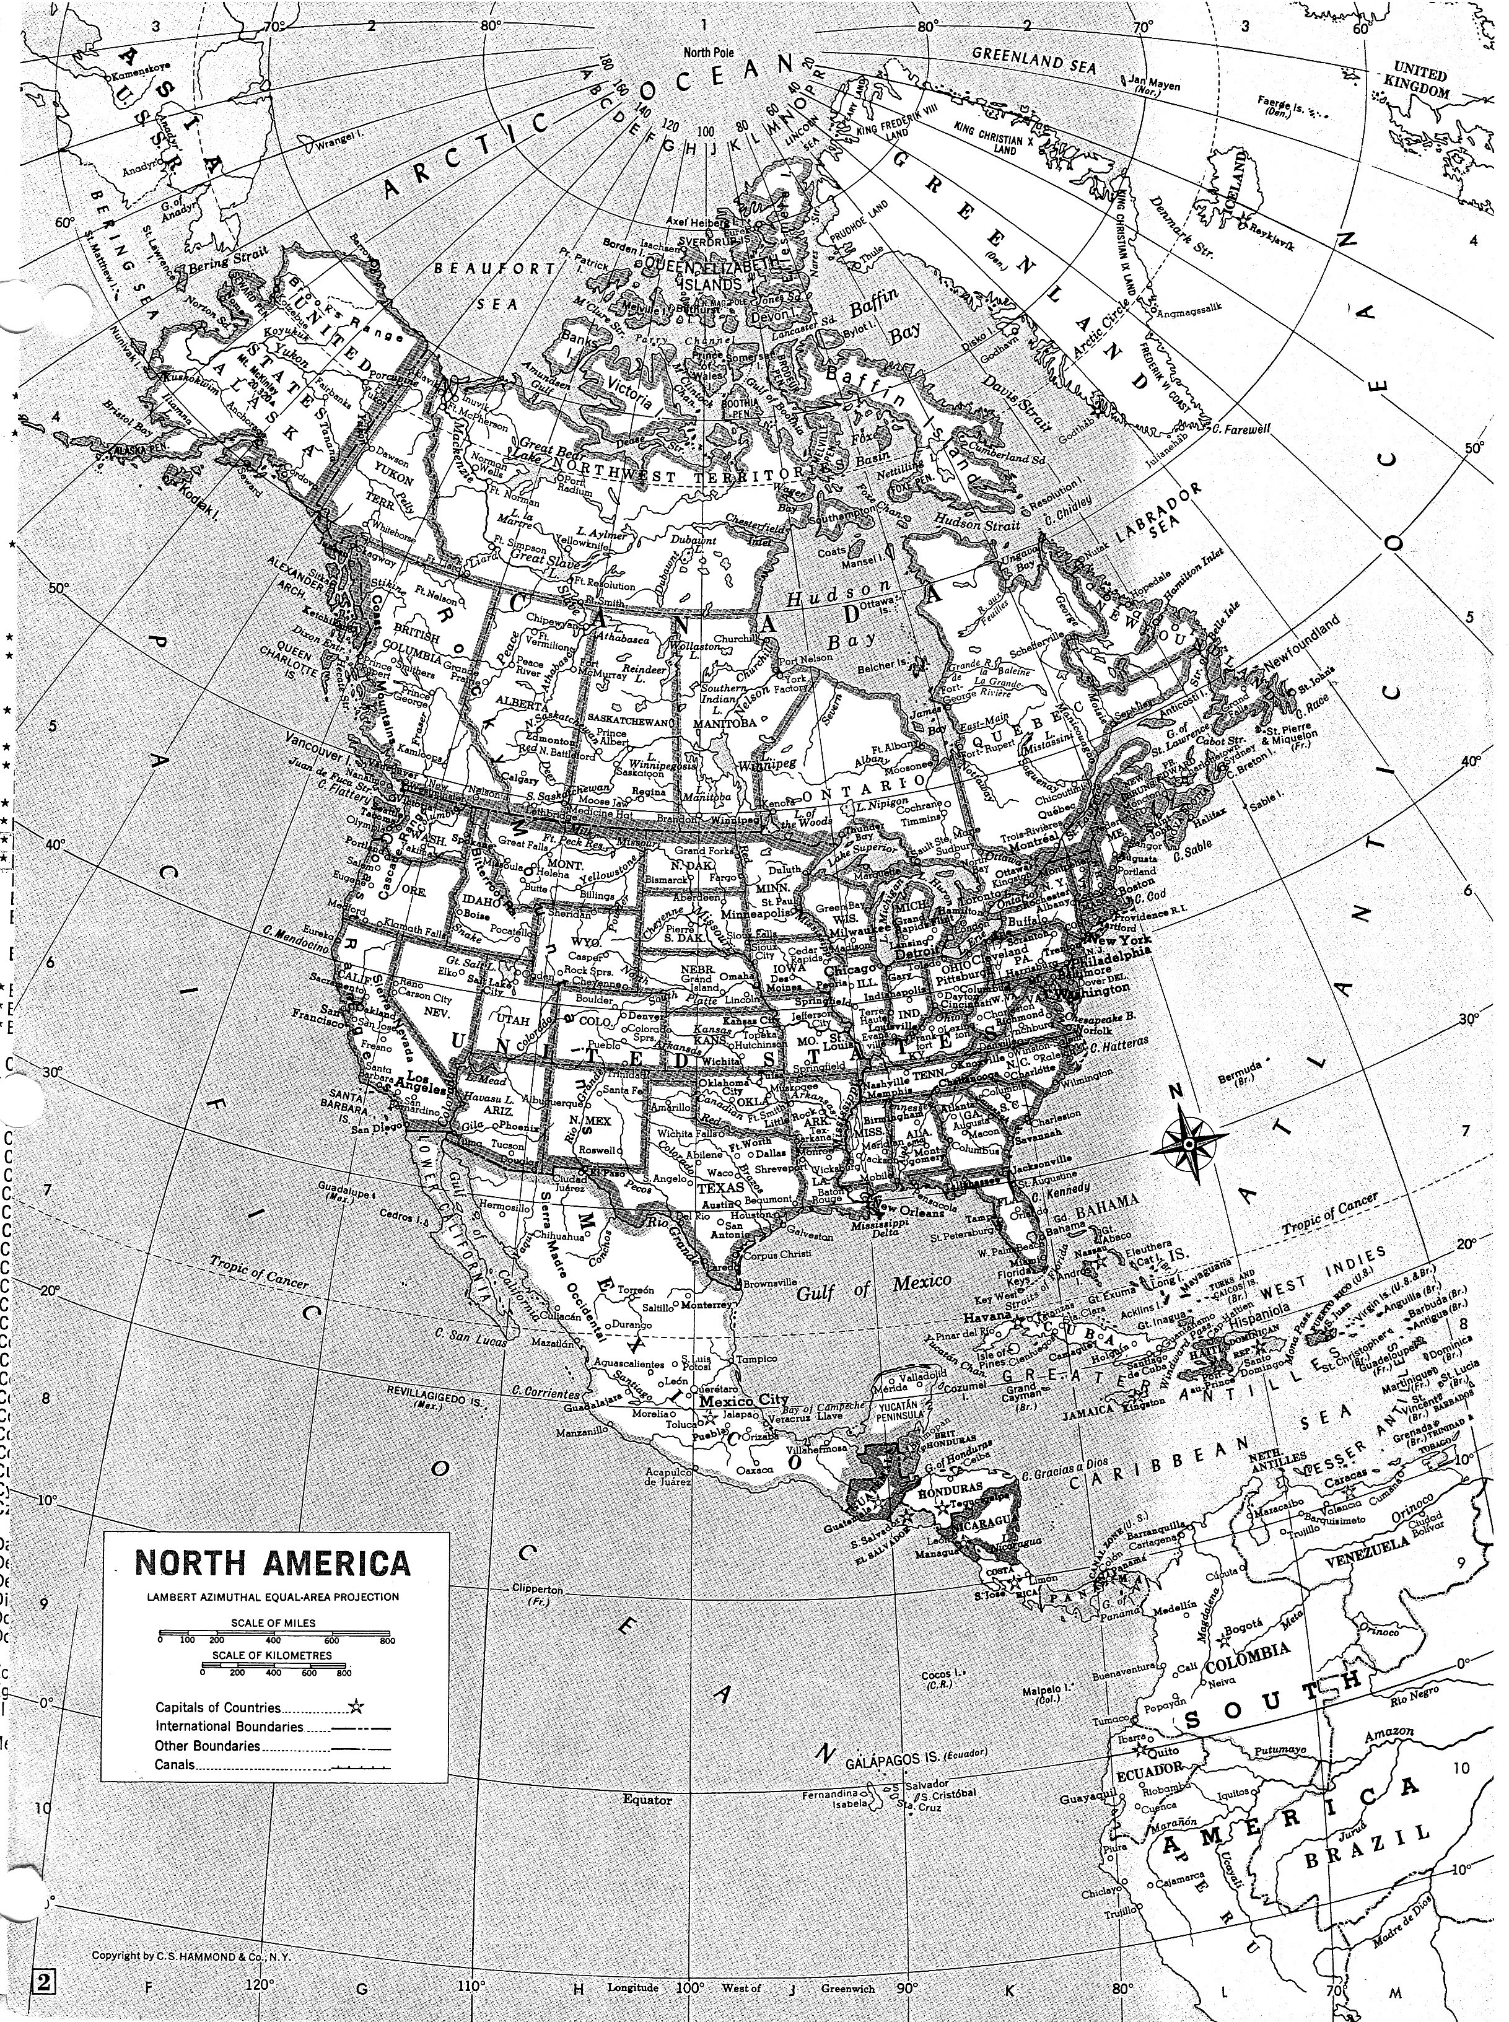

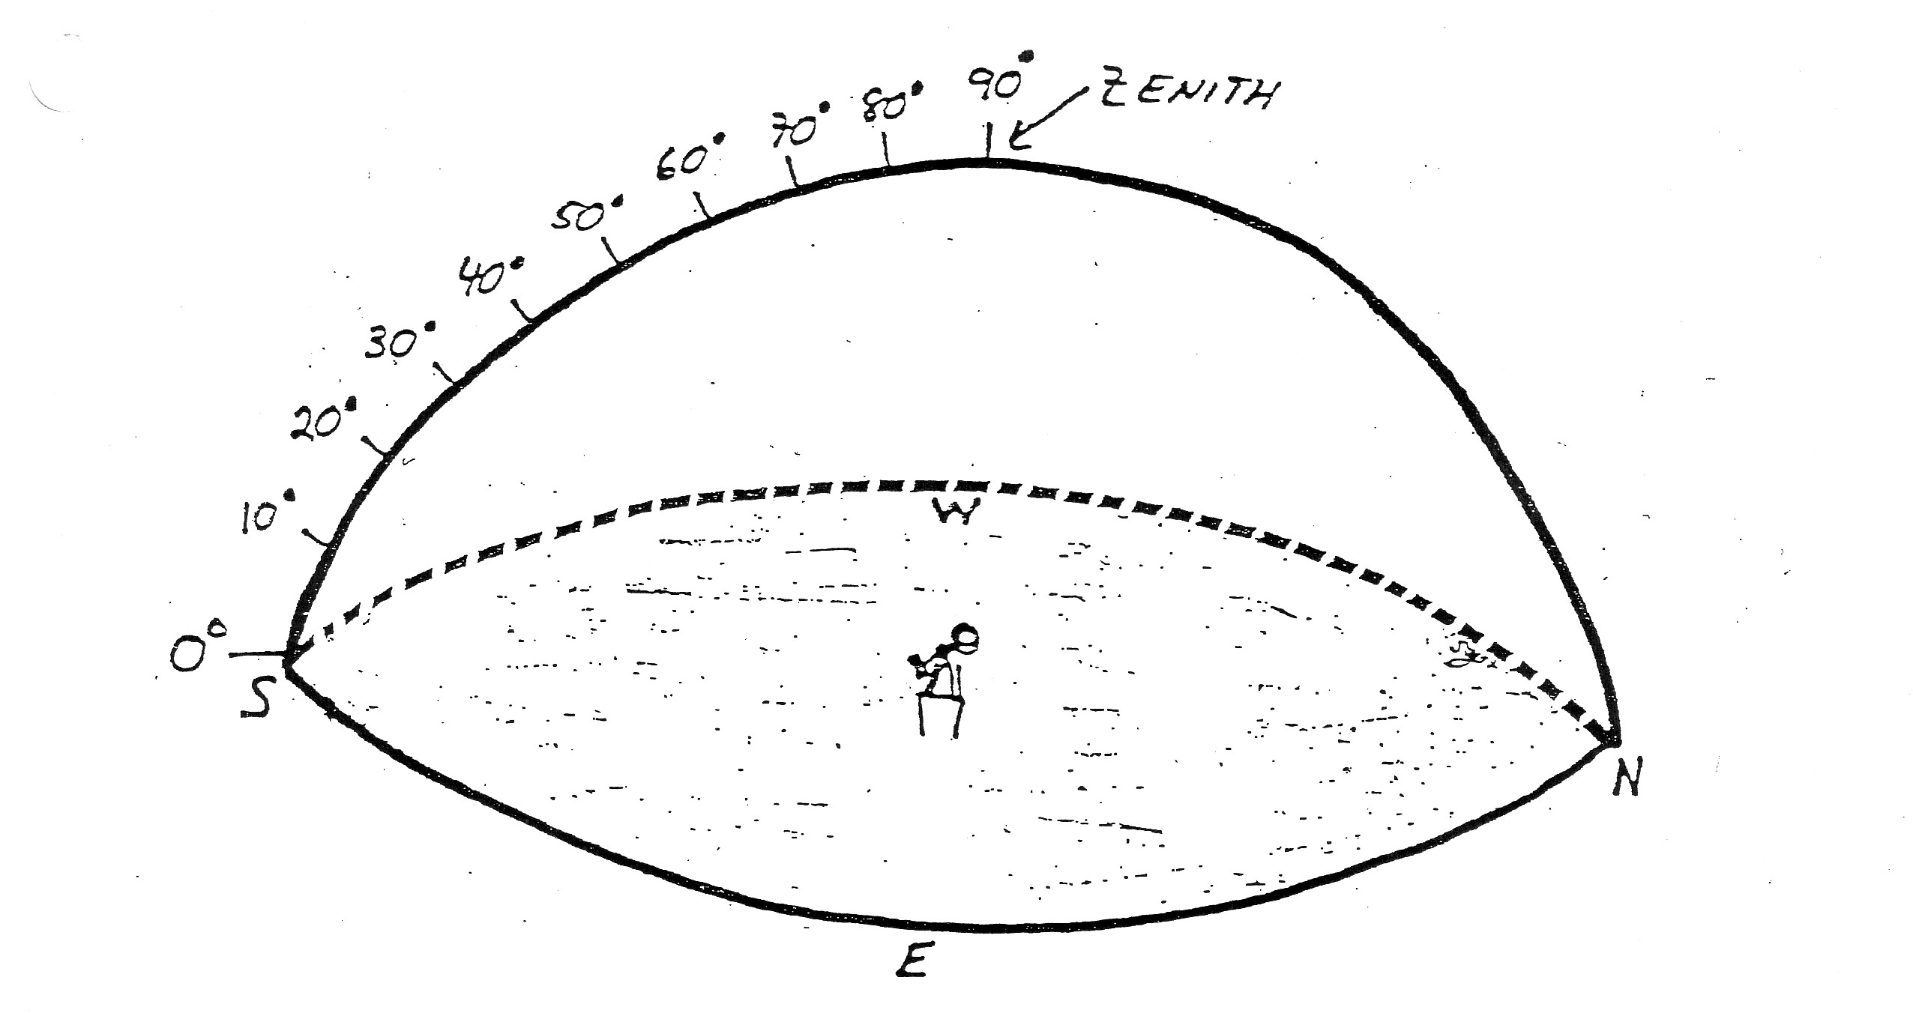
E
N
0º
0º
E
#1
#2
Location:____________
Latitude: ____
Location:____________
Latitude: ____

S
N
S

W
W

ALTITUDE OF POLARIS AT 6 DIFFERENT LOCATIONS ON EARTH
#3
#4

Location:____________
Latitude: ____
Location:____________
Latitude: ____

0º
E
E

N
N
S
S

W
W
#5
#6

Location:____________
Latitude: ____
Location:____________
Latitude: ____
N
N
S
S
W
W
E
E

DATA TABLE OF LOCATIONS VISITED
Location | Latitude | Altitude of Polaris

ANALYSIS: Make a line graph of your data. Remember what the experimenter is most interested in should be plotted on the Y-axis.

CONCLUSION:
Write a summary paragraph that answers the question, “How does the altitude of Polaris change with latitude?” You should use R.A.F.T. (Restate, Answer, For example, & Tie it up) You may have a drawing or diagram to help explain your answer.

Bonus opportunity: Write a second paragraph explaining why the altitude of Polaris changes with latitude and how it would change if the Earth were flat.

